Exercise 1: Control Structures

Creating Schema, Tables and Inserting Values
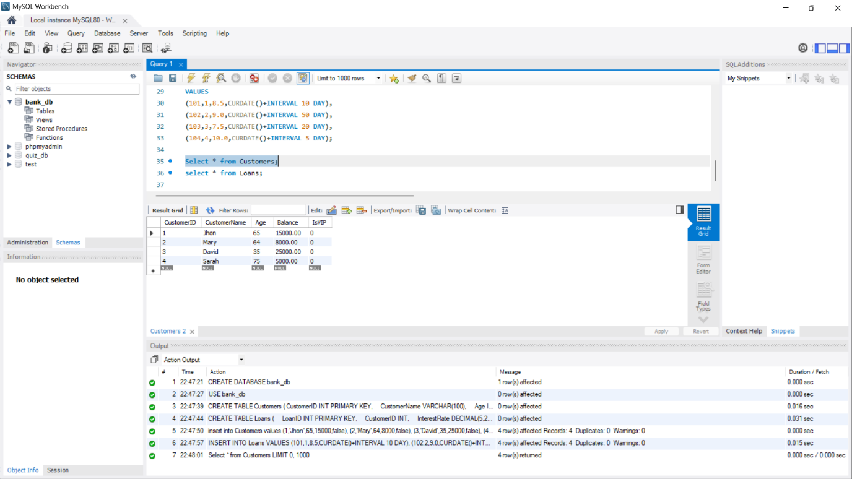

OUTPUT – Scenario 1
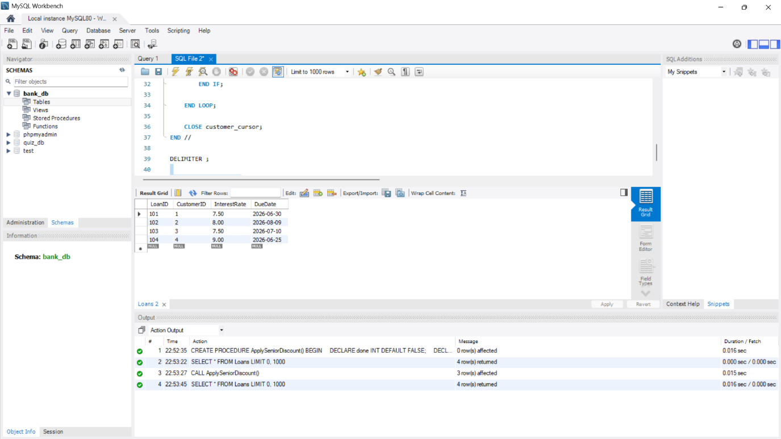

OUTPUT - Scenario 2
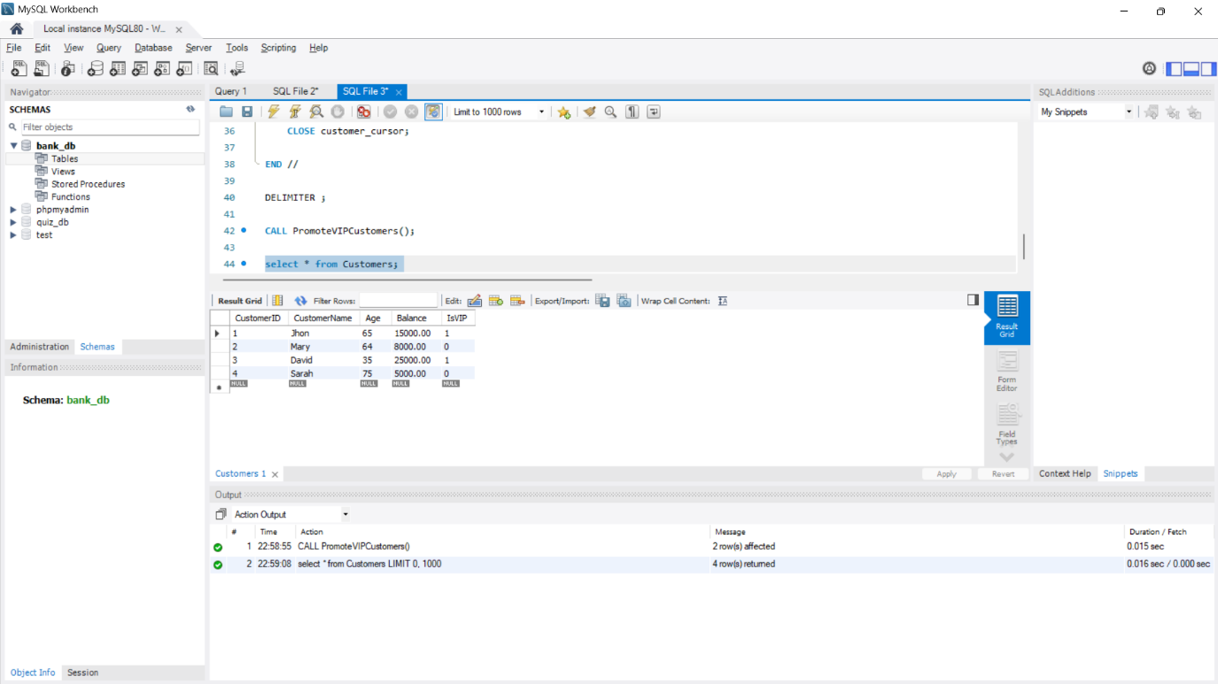

OUTPUT – Scenario 3
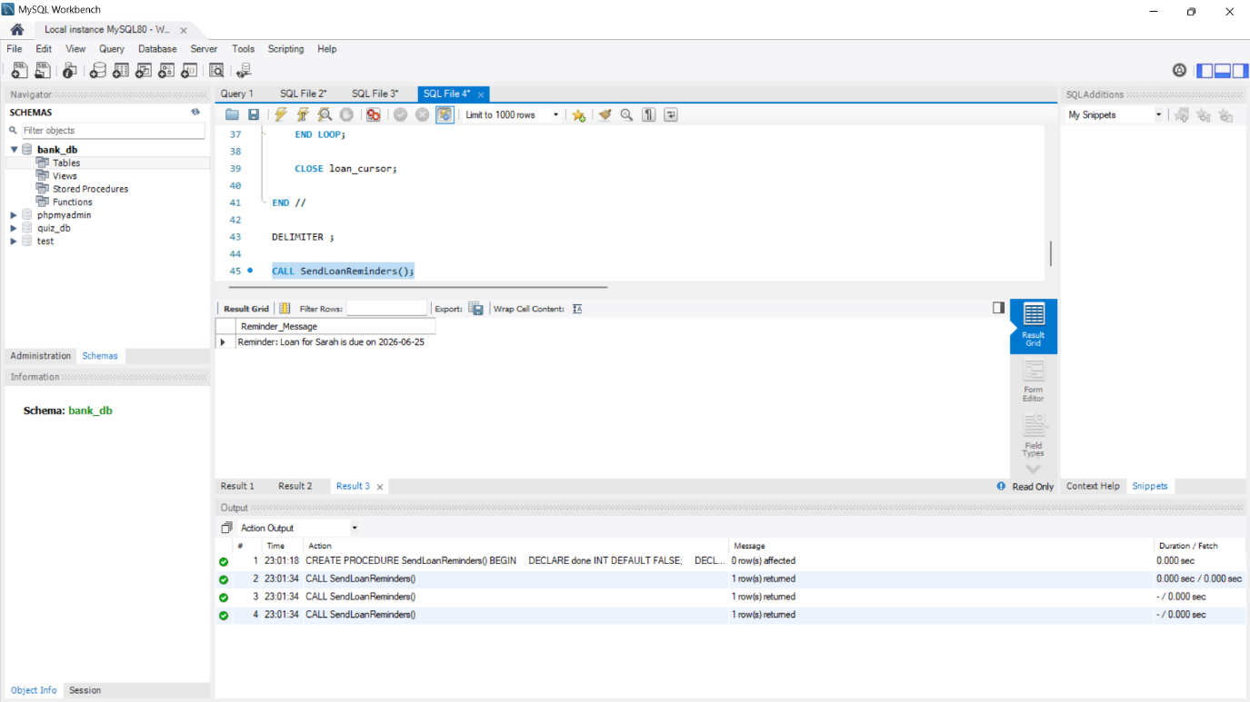

Exercise 3: Stored Procedures

Using the prev “bank_db” and inserting values to new table “Accounts”
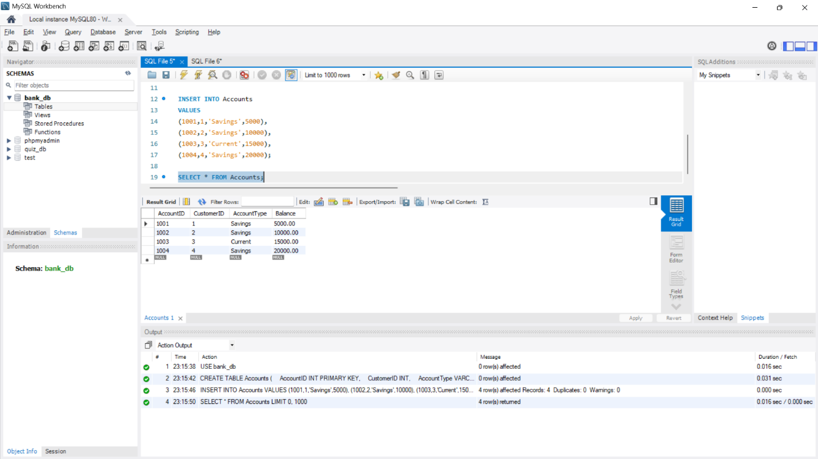

OUTPUT Scenario - 1
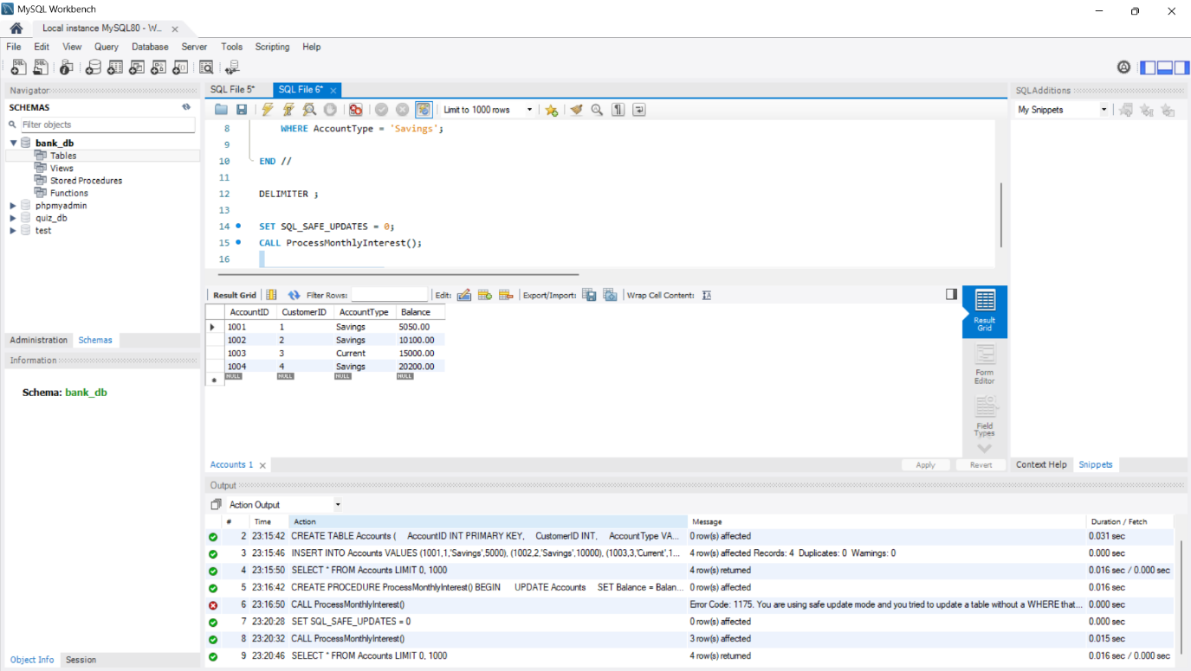

OUTPUT Scenario – 2
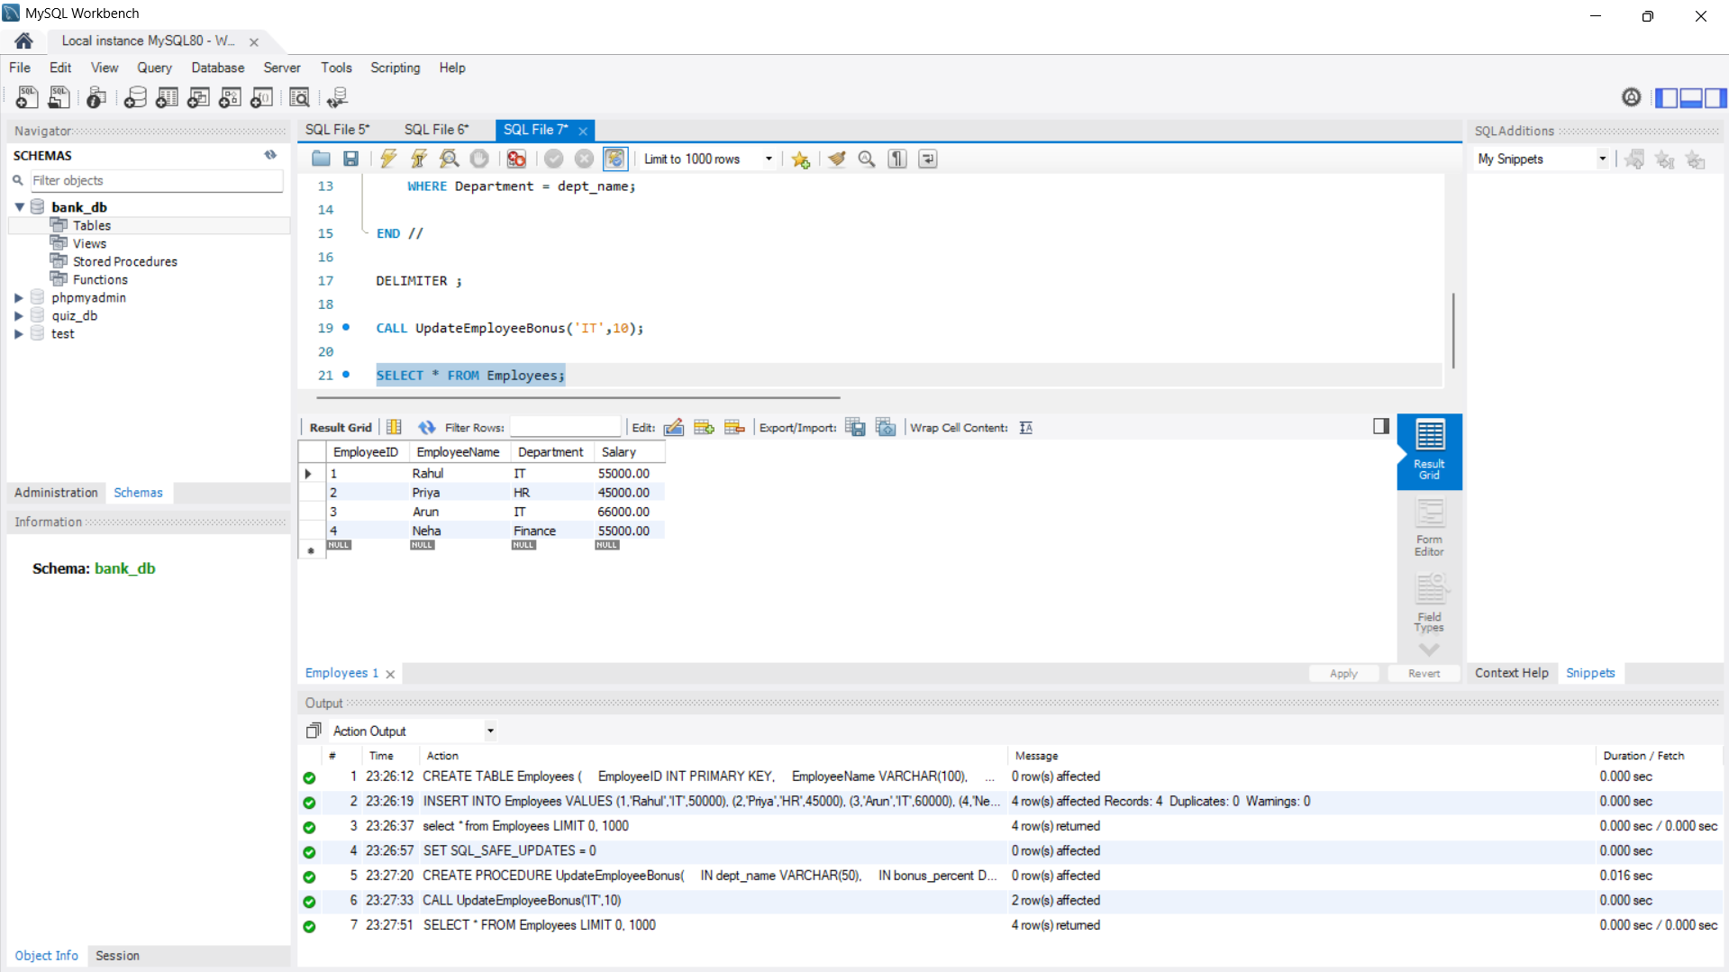

OUTPUT Scenario – 3
